Docker

# Introdução ao tema

## VM e Container

**Terminologias**

* Container image;
* Dockerfile;
* Build;
* Container;
* Volumes;
* Tag;
* Multi-stage Build
* Repository;
* Registry;
* Docker Hub;
* Compose;

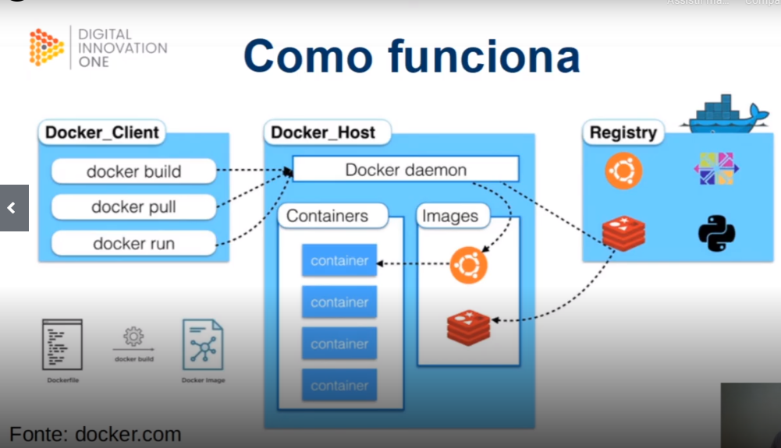

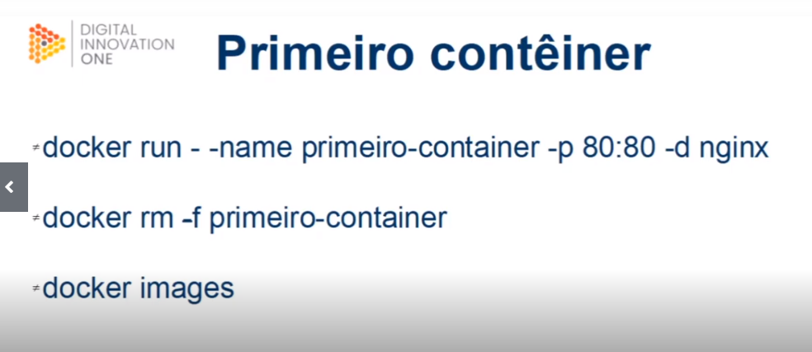

Docker status

Docker ps

Docker help

Docker stats

Ctrl + c

Ls

Pwd => /root

docker run --name meu-primeiro-container -p 80:80 -d nginx

docker images

docker ps

docker rm -f “nome”

docker rmi nginx

**Primeiros comandos**

run

os

info

images

exec

stop, start

logs

inspect

pull

commit

tag

login, logout

push

search

rm

rmi

export, import

save, load